A Report on one day
International Workshop
on
“Open Source Innovations –Technological Convergence by RED HAT ACADEMY”
12 October , 2017
at
Jaipur Engineering College and Research Centre, Jaipur

Organized By: Departments of ECE
Objective:
To aware research scholars, students and faculty members about the
- Brief Introduction of Red Hat
- Various career opportunists available in the market apart from Networking jobs
- Market significance of red Hat certification
- Career opportunities with red Hat certifications
- Training In campus is much better than training after Graduation/Masters
Target:
Faculty members, Research Scholars, Post-Graduate and Under-Graduate students of ECE, CSE, IT and EE departments.

Summary:
The ECE department of Jaipur Engineering College and Research Centre organized an International workshop on “Open Source Innovations –Technological Convergence by RED HAT ACADEMY” 17 january to 30 january at Auditorium A-Block.

The inaugural function was graced by the presence of Chief Guest Mr. Alok Srivastava, Director, Network Nuts-Red Hat Partner; Guest of Honour Sh. O. P. Jain, Senior Advisor, JECRC; Sh. M. L. Sharma, Vice Chairman, JECRC; and Prof. V. K. Chandna, Principal JECRC, Jaipur.
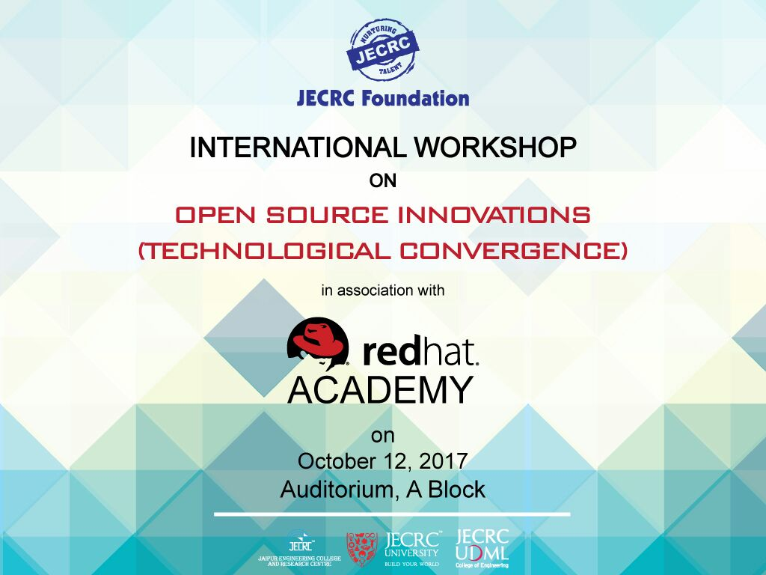
The program started at 10:00 am with the inauguration and lighting of lamp by the esteemed guests and the dignitaries, followed by the presentation of bunch of flowers to the Chief Guest and the Guest of Honour by Prof. V. K. Chandna.
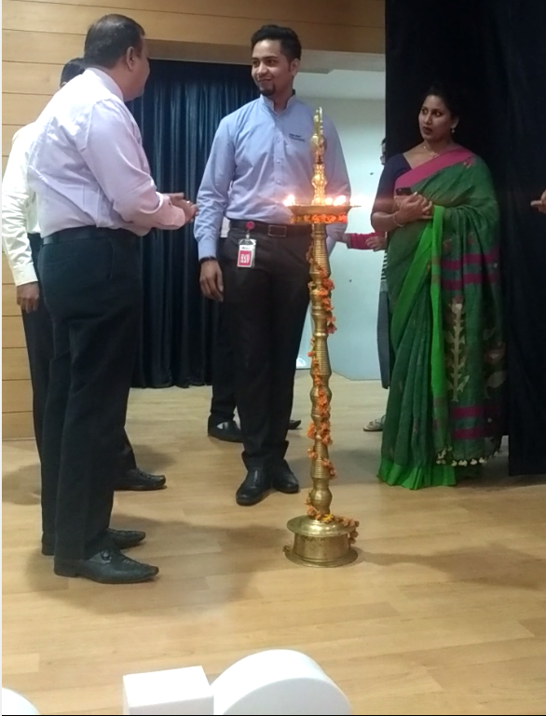
The program initiated with the welcome speech by Dr. Lokesh Kumar Bansal, HoD-ECE, who briefed the audiences about the Workshop and dignitaries.
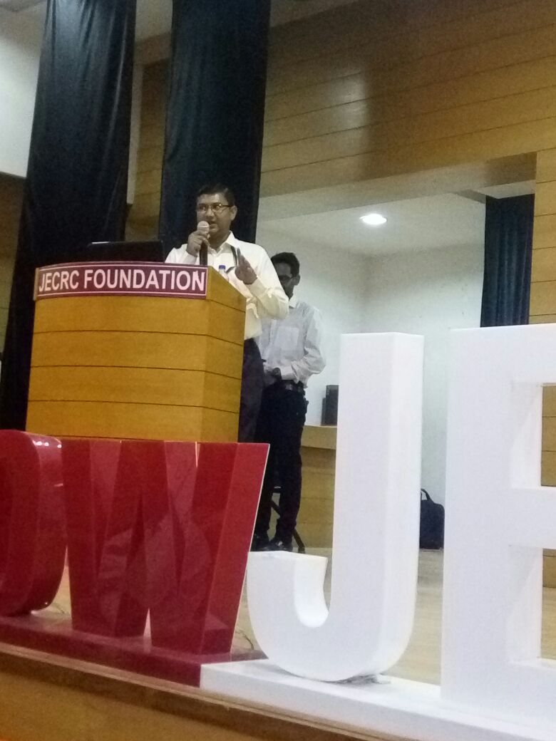
After the welcome address, honorable Principal Dr. V. K. Chandna addressed the gathering. In his address Dr. Chandna emphasized on such type of workshop as they help in the overall growth of the students and research scholars involved in the field of ECE, CSE, IT and EE.
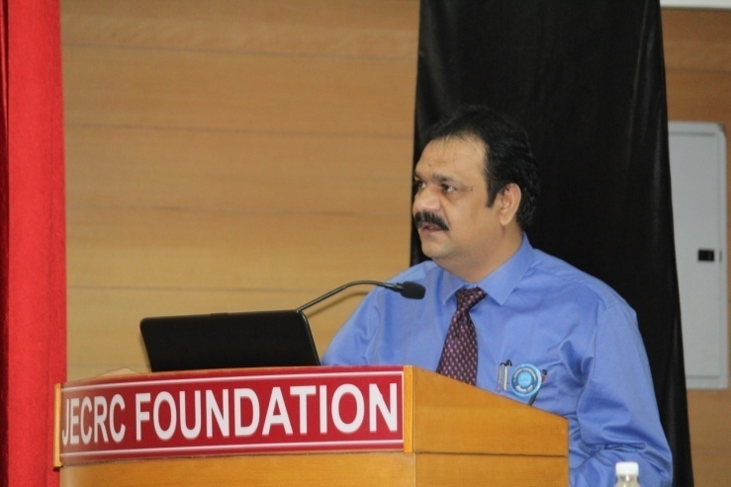
After the wisdom words of Principal Dr. V. K. Chandna, the Guest of Honour Sh. O. P. Jain, Senior Advisor, JECRC addressed the gathering. Mr. Alok Srivastava (Director, Network Nuts-Red Hat Partner) told about the recent developments in the field of operating system and the excessive use of Linex RedHat in around 95% of the industries. He also compare the use of linex and driving his Harley Devidson. He also suggest 5 rules for safer driving and how he use them while learning linex.
Thereafter Mr. Gulshan Prasad – Technical Consultant, Red Hat address the gathering about, Red Hat the future Technologies. He spoke about the future trends of Red Hat.
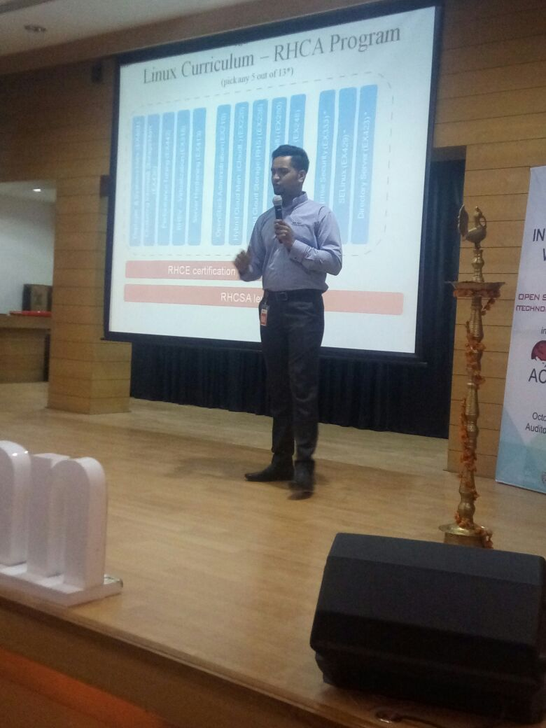
After remarkable presentation of Mr. Gulshan Prasad, Ms . Menta Simon (Director Operations Network Nuts-Red Hat Partner), spoke about Red Hat Academy and its Certifications programs.

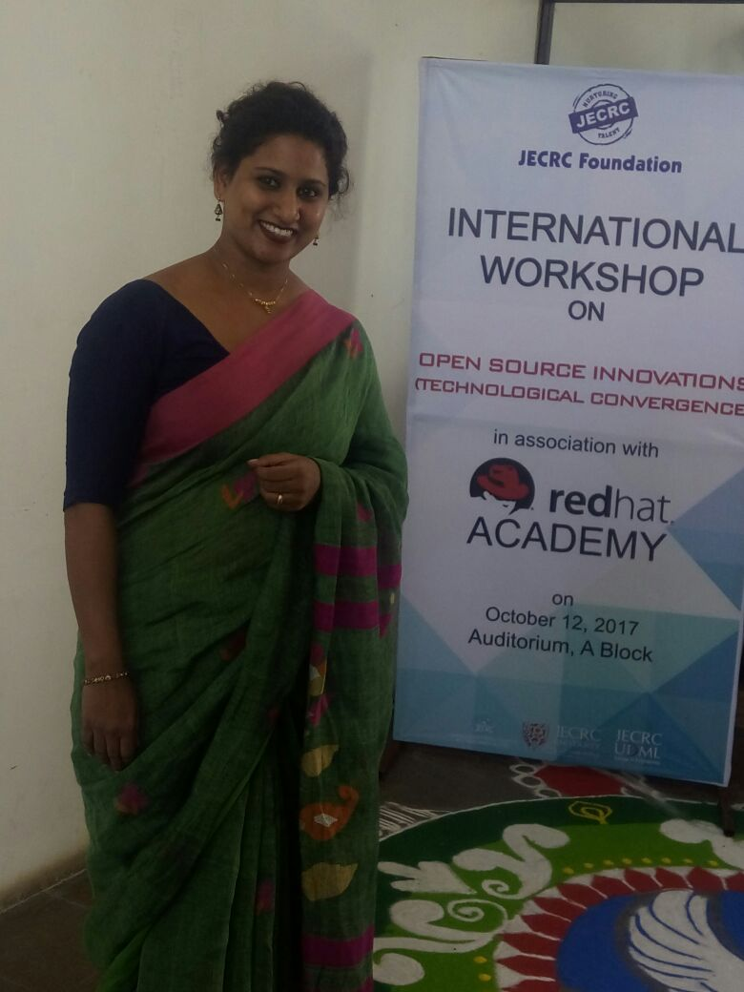
The status of the participants are .

participant | Total Numer
JECRC students | 107
Within Rajasthan outside JECRC | 47
Outside Rajasthan | 28
Internal (Faculty Members) | 25
Foreign students | 10
Total Participant | 217
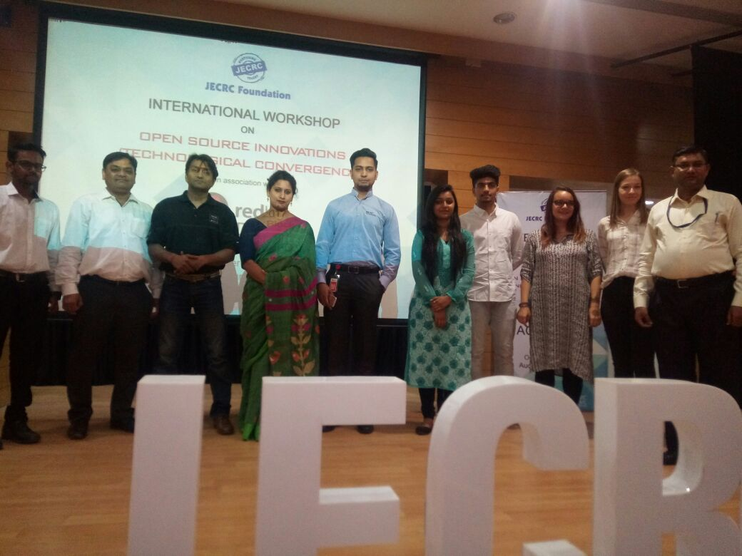
Valedictory Function
Prof. S. N. Gupta, ex-Dean of Mody University, Laxmangarh was the Chief Guest of valedictory function. Respected Shri Amit Agrawal, Director, JECRC Foundation, Shri Arpit Agrawal, Director, JECRC, Prof. V. K. Chandna, Principal JECRC, Jaipur, Prof. Victor Gambhir, Vice Chancellor, JECRC University, and other dignitaries were present.
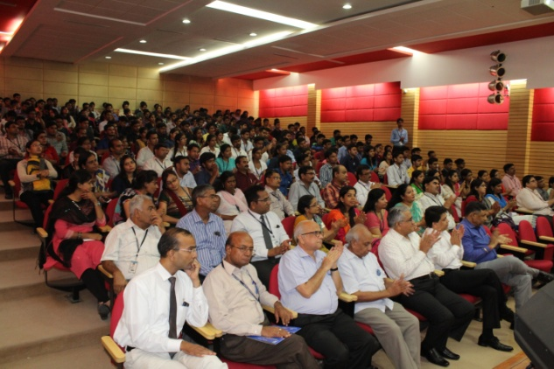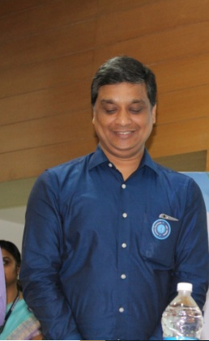

Honorable Shri Amit Agrawal, Director, JECRC Foundation briefed about the bio data of Prof. S. N. Gupta. After that Chief Guest Prof. S. N. Gupta addressed the gathering and brief about the advantages of research, participation in workshop and shared with us of his some PhD experiences.
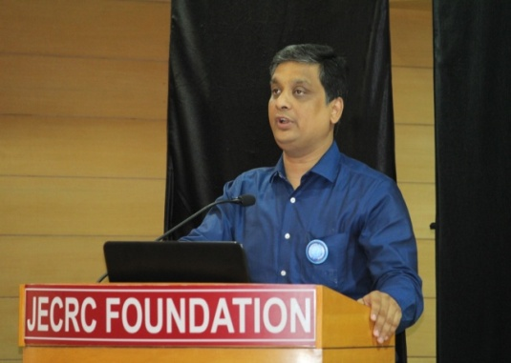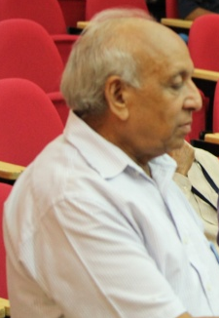
Participants were given certificates for attending workshop
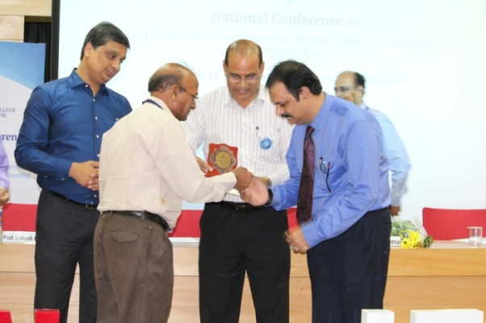

Outcome:
- Students and research scholars were made aware about the RedHat linex operating system.
- Students knew about the benefits of such workshop so that they may get an insight into the field of linex which is an essential factor for the advancement of their career.
Scope for Improvement:
- Internationally renowned speakers may be call as resource persons.
- More no of participant can be gathered.
- Some hands on practice can be organized.

